Experiment 3.3
Autocorrelation
Aim:
To compute and analyze the autocorrelation of a discrete-time sequence using MATLAB.
The Aim is to understand how autocorrelation can be used to measure the similarity of a
signal with a time-shifted version of itself, providing insights into the periodicity, energy
distribution, and signal structure.
Program:
% Autocorrelation of a Signal
clc;
clear;
close all;
% Input Signal
x = [1 2 3 4 5];
% Autocorrelation
Rxx = xcorr(x);
% Lag values
lags = -(length(x)-1) :(length(x)-1);
% Display result
disp('Autocorrelation Sequence:');
disp(Rxx);
% Plot
figure;
stem(lags,Rxx,'filled');
grid on;
title('Autocorrelation of Signal');
xlabel('Lag');
ylabel('R_{xx}(k)');

Output Waveform:
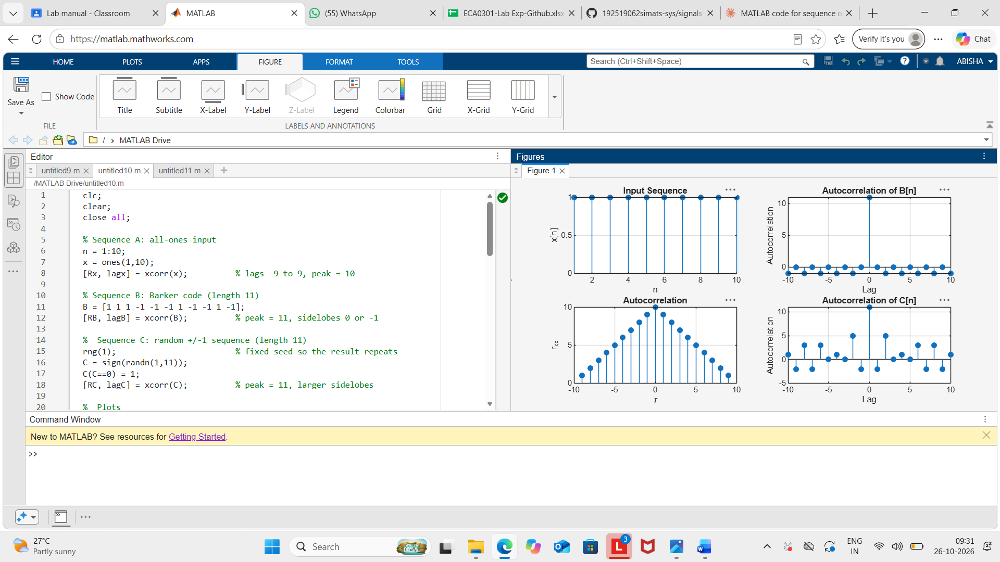

Result:
The autocorrelation of the given discrete-time signal was computed using MATLAB. The
autocorrelation sequence was symmetric about zero lag, and the maximum value occurred at
zero lag, indicating the highest similarity of the signal with itself.

